NAME: NAVODITAA A.R
ROLL NO: 241901071

3. NETWORK SECURITY ESSENTIALS
DATE: 11/02/2026
Aim:
To learn about key aspects of network security essentials and how to monitor and protect against adversaries.
Procedure:
- Log into TryHackMe and open the Network Security Essentials room.
- Study basic network security concepts including firewalls, IDS, and IPS.
- Understand common network threats such as malware, phishing, and DDoS attacks.
- Learn monitoring techniques using logs and traffic analysis.
- Explore methods to protect networks from adversaries.
- Complete the tasks and answer the questions in the room.
- Review the summary and confirm completion.
Tasks:
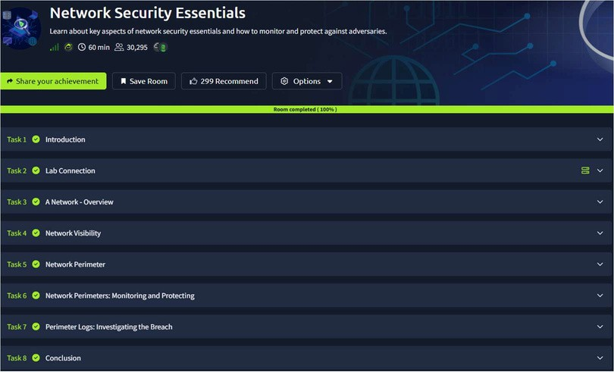
TASK 1 - Introduction
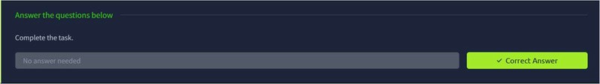
TASK 2 – Lab Connection
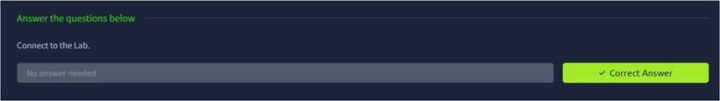

TASK 3 – A Network-Overview
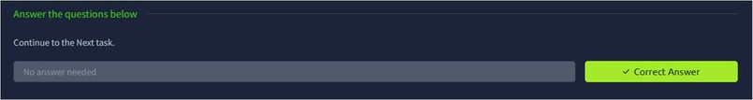
TASK 4 – Network Visibility
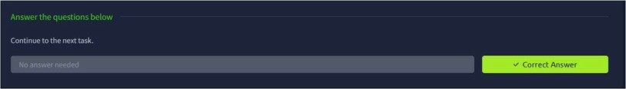
TASK 5 – Network Perimeter
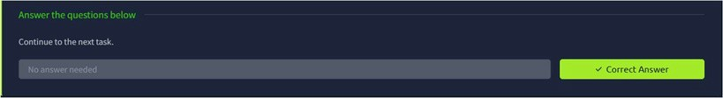
TASK 6 – Network Perimeters : Monitoring and Protecting
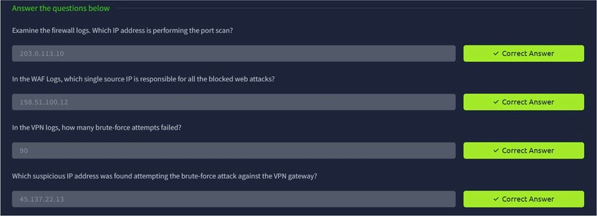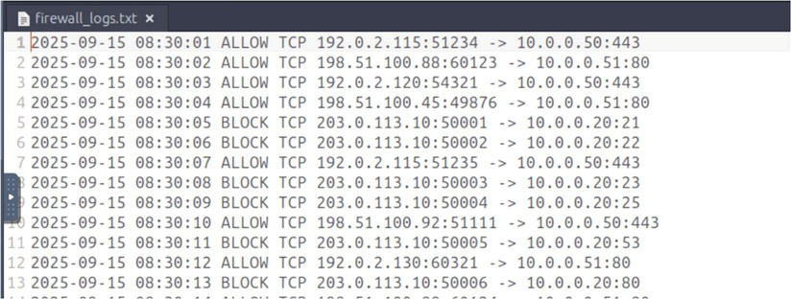

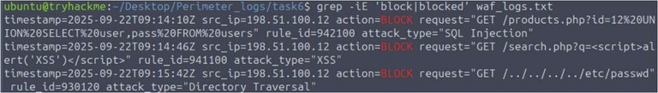
TASK 7 – Perimeter Logs : Investigating The Breach
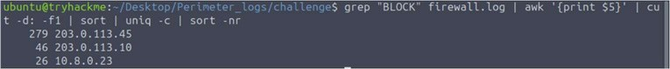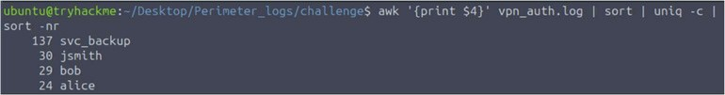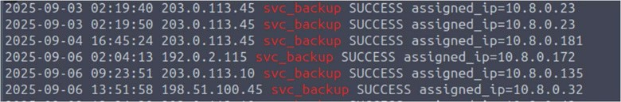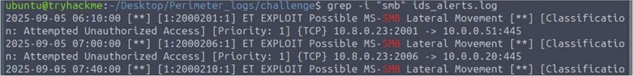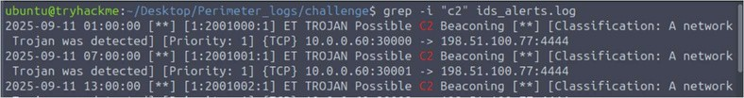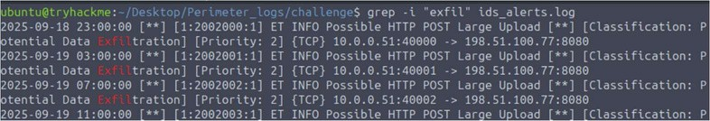

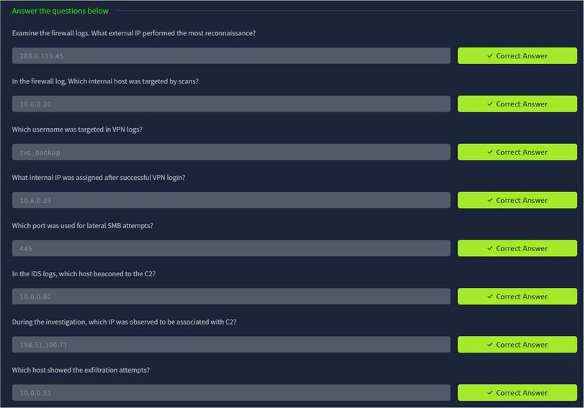
TASK 8 - Conclusion
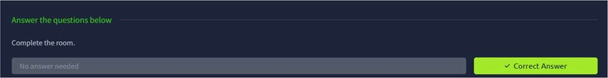
Result:
Thus the TryHackMe room “Network SecurityEssentials” was completed successfully.

